# File permissions in Linux

## Project description

Using linux you can easily change file permission for the Users, groups and others needing to access files or applications.

## Check file and directory details

ls -la

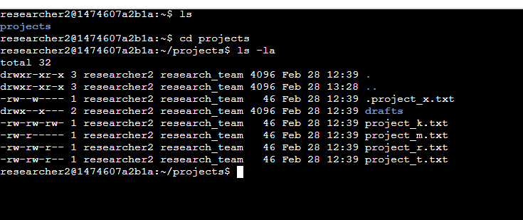

## ls -la is a command that will show you the file permission of each file in a directory. The string at the front of each line will tell you the file type and permission. It will also tell you the owner, and the group/team that the user is in.

## Describe the permissions string

The permission string is at the front of each line and describes the file type and permissions each file has.

d - in front tells you that it is a directory file. While a - up front tells you that it is a regular file.

The next 9 spaces in the string give you the read, write, and execute permission on the file.

r is the read permission, w is the write permission, x is the execute permission. If there is a dash instead of rwx, then the user, group, or other does not have that permission.

The first 3 are for the user, the middle 3 are for the group, and the last 3 are for others.

For instance project_k.txt users, group, and others all have read and write permission.

## Change file permissions

chmod o-w project_k.txt

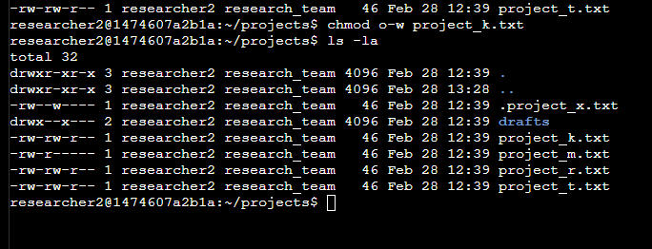

## project_k.txt permission was changed. Before the permission string was -rw-rw-rw. The chmod subtracted the write permission from the other group.

## Change file permissions on a hidden file

chmod u-w,g-w .project_x.txt

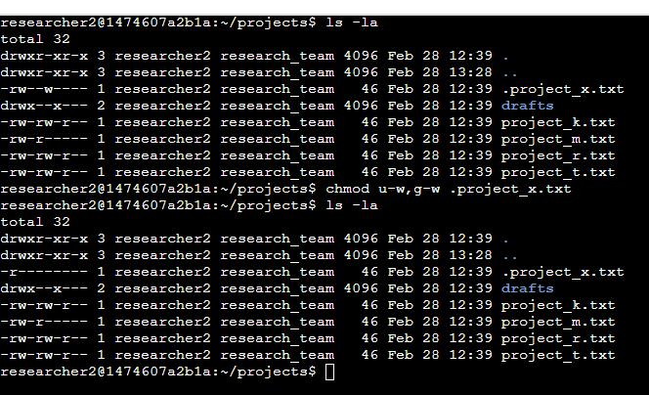

## Change directory permissions

chmod g-x drafts

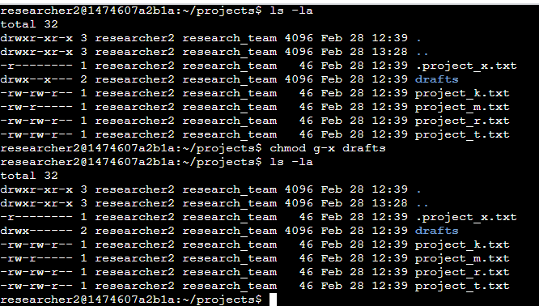

## Now only the user ‘researcher2’ can access drafts.

## Summary

I changed multiple permissions to match the level of authorization my organization wanted for

les and directories in the projects directory. The first step in this was using ***ls -la*** to check the permissions for the directory. This informed my decisions in the following steps. I then used the **chmod** command multiple times to change the permissions on file and directories.